Supplementary Materials for
Gut microbiome signatures of nursing home residents carrying Enterobacteria Producing Extended-spectrum β-lactamases

Le Bastard Q^{1,2}, Chapelet G^{1,3}, Birgand G^{1,4}, Hillmann B⁵, Javaudin F^{1,2}, Hayatgheib N¹, Bourigault C^{1,6}, Bemer P^{1,6}, De Decker L^{1,3}, Lepelletier D^{1,6}, Batard E^{1,2}, Montassier E^{1,2}

This file includes:
Laboratory methods, Supplemental figures 1 to 5, Captions for Additional data tables 1 to 5 (comma separated values .txt files)

Laboratory methods
Samples were addressed and managed in the laboratory of Bacteriology, Nantes University Hospital, for identification of ESBL, according to CLSI guidelines. Samples were vortexed and cultured for 24 hours on specific chromogenic agar culture medium (ESBL-chromID, Biomérieux, France). Colonies were identified using mass spectrometry (MALDI-TOF MS method, Bruker Daltonics, Germany). ESBL-E phenotypes were confirmed by detection on disc diffusion tests (MASTDISCSTM D72C ID ESBL test, Mast Diagnostics, Merseyside, UK).

Supplementary Figure 1. ESBL-E carriers and non-carriers harbors non-significantly different relative abundance of K. pneumoniae, E. cloacae and E. coli. Individual plots of relative abundance of the three species identified as extended spectrum beta-lactamase producers in ESBL-E carriers. Comparison of relative abundances between ESBL-E carriers and non-carriers shows no significant differences (Mann-Whitney U test, ESBLE-E carriers versus non-carriers for E. coli, E. cloacae and K. pneumoniae relative abundances, all p values > 0.05)
S1
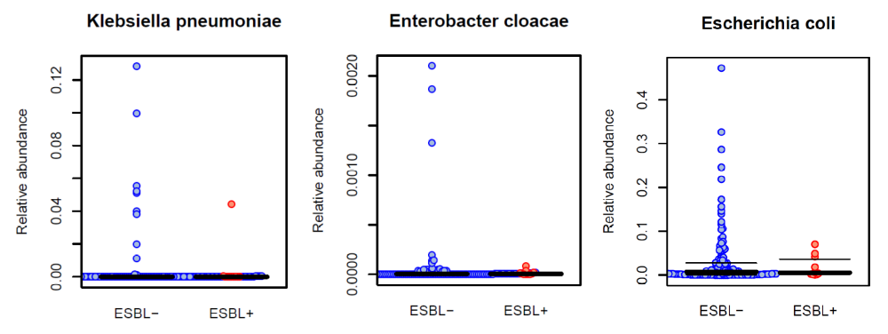

Supplementary figure 2. ESBL-E carriers and non-carriers have a distinct gut microbial composition. Beta-diversity comparisons of the gut microbiomes of extended spectrum beta-lactamase producing Enterobacteriaceae (ESBL-E) carriers and non-carriers. The first two axes are shown of principal coordinate analysis (PCoA) of Bray Curtis distances between individual communities at species level. The proportion of variance explained by each principal coordinate axis is denoted in the corresponding axis label. The plot shows a significant separation between samples from ESBL-E carriers and non-carriers (analysis of similarities, ANOSIM, R=0.177, p value=0.048).
S2
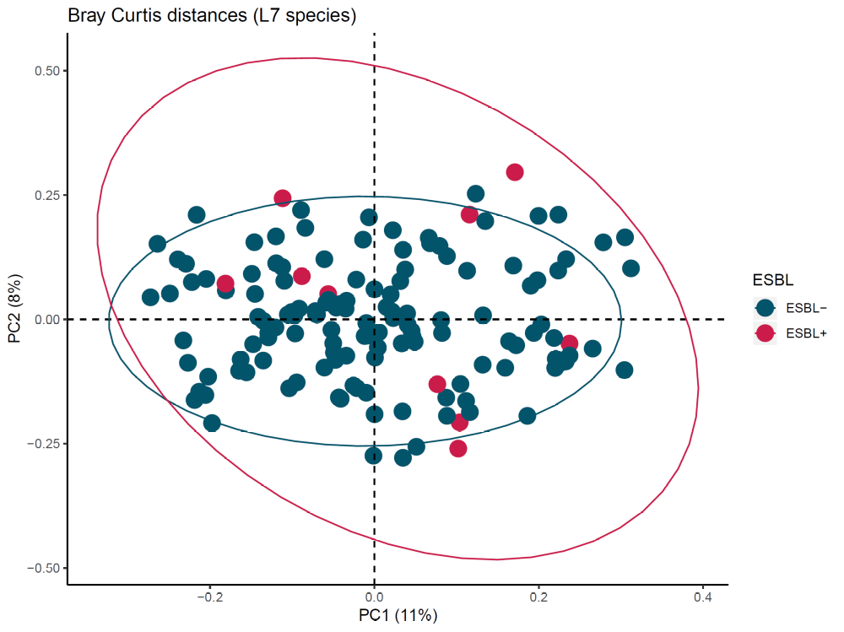

Supplementary figure 3. Analysis of within samples functional biodiversity shows an increased biodiversity in the gut microbiome of ESBL-E carriers. Alpha-diversity indices in gut microbiomes of extended spectrum beta-lactamase producing Enterobacteriaceae (ESBL-E) carriers and non-carriers., based on KEGG KO. Whiskers in the boxplot represent the range of minimum and maximum alpha diversity values within a population, excluding outliers. Monte-Carlo permutation t-test: *p value <0.05; ** p value <0.01; and *** p value <0.001. Boxplots denote top quartile, median, and bottom quartile.
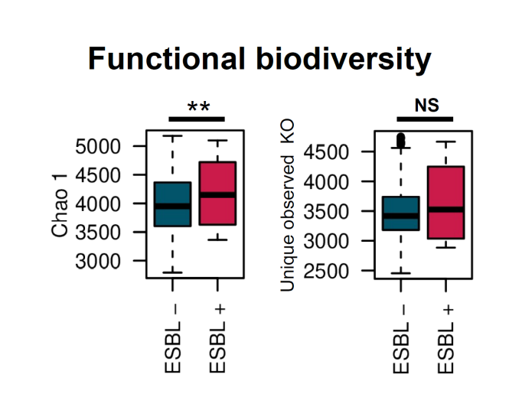
S3

Supplementary figure 4. KEGG KO that differentiate Enterobacteriaceae (ESBL-E) carriers and non-carriers at genus level, using DESeq2 with bootstrap iterations. The bootstrap model consists in 50 random selections of non-carriers (n = 40). We represented the KEGG KO that are significantly different between ESBL-E carriers and non-carriers in more than 40 iterations in the 50 performed, with a FDR corrected p value < 0.10.
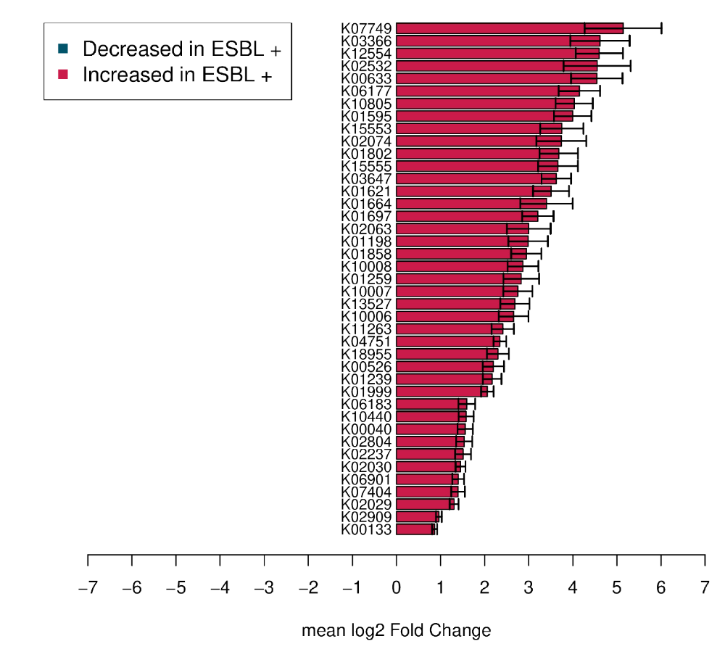

Supplementary figure 5. CAZyme that differentiate Enterobacteriaceae (ESBL-E) carriers and non-carriers at genus level, using DESeq2 with bootstrap iterations. The bootstrap model consists in 50 random selections of non-carriers (n = 40). We represented the CAZymes that are significantly different between ESBL-E carriers and non-carriers in more than 30 iterations in the 50 performed, with a FDR corrected p value < 0.10.
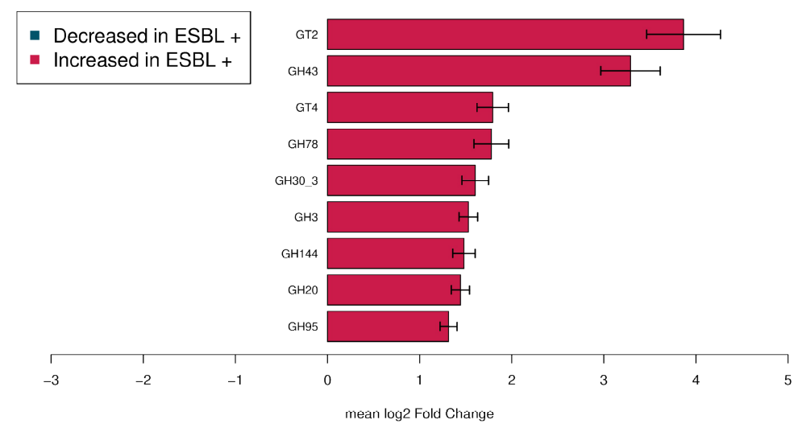

Supplementary table 1. Genus that differentiate carriers and non-carriers using DESeq2 with bootstrap iterations.
Supplementary table 2. Species that differentiate carriers and non-carriers using DESeq2 with bootstrap iterations.
Supplementary table 3. KEGG modules that differentiate carriers and non-carriers using DESeq2 with bootstrap iterations.
Supplementary table 4. KEGG KO that differentiate carriers and non-carriers using DESeq2 with bootstrap iterations.
Supplementary table 5. CAZyme that differentiate carriers and non-carriers using DESeq2 with bootstrap iterations.

